YEAR 10 SCIENCE (GENERAL)
EXAMINATION REVISION - SEMESTER 2 2012

Natural and Processed Materials

1. The periodic table is useful for chemists as it arranges the elements in a particular way.

(a) What is a group?

(b) Why are elements put into a particular group?

(c) What are the group numbers of:

(i) alkali metals?

(ii) inert (noble) gases?

(iii) halogens?

(d) Where do you find the following elements in the table? Indicate them on the periodic table below, either
by labelling or colouring.

(i) transition elements
(ii) metalloids / semi-metals

(e) Where do you find the non-metal elements? Show this on the diagram below.

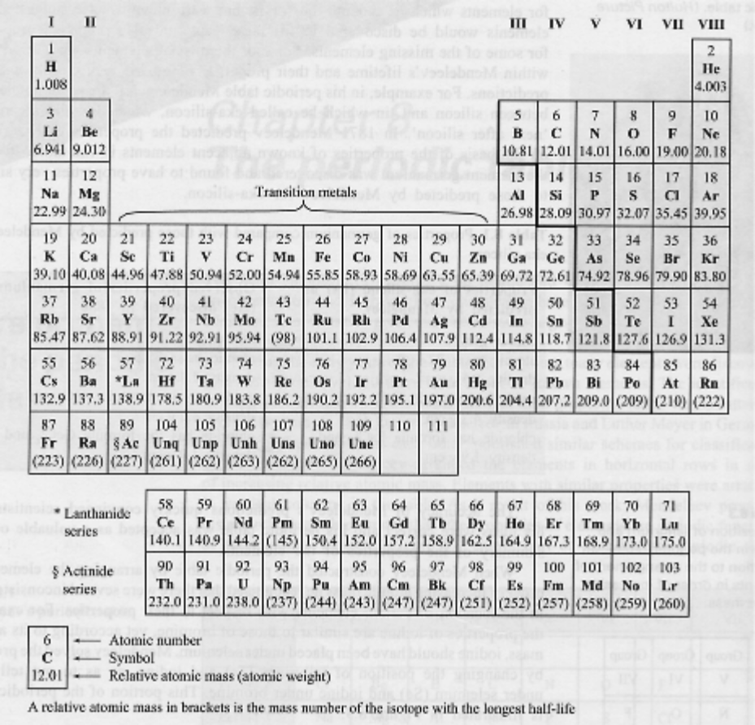

2. Give a definition or description for the following terms.

(a) element

(b) atomic number

(c) atomic mass

(d) ionic bond

(e) covalent bond

(f) valence electron

(g) Octet Rule

3. Complete the following table.

ELEMENT | PROTON NUMBER | NEUTRON NUMBER | ELECTRON NUMBER
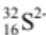
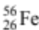
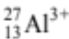

4. Draw clear diagrams to show the electron configurations of the following elements.

(a) 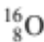 (b) 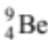

(c) 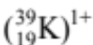 (d) 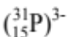

5. can form a 2- ion (O²⁻).

(a) Were electrons gained or lost to form the O²⁻ ion?

(b) How many electrons were gained or lost?

(c) In which group is O?

(d) What valency do all members of this group possess?

(e) Explain carefully why the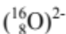 ion is stable, referring to the Octet Rule.
(HINT: Some mention of the noble or inert gases would be appropriate!)

6. Complete the table below by either writing a formula or name as required. Most are ionic compounds
and the rest are covalent molecules. For the ionic substances, show the ions used and your working.

COMPOUND | FORMULAE
iron (III) chloride
magnesium iodide
 | Fe(NO₃)₃
barium carbonate
ammonium sulphide
 | Al(OH)₃
lead (II) sulphate
potassium acetate
 | Zn₃(PO₄)₂
copper (ii) sulphate
sulphur trioxide
diphosphorus pentoxide
 | SF₆
nitrogen dioxide

7. Balance the following equations.

(a) MgO_{(s)} + HNO_{3(aq)}  Mg(NO₃)_{2(aq)} + H₂O_{(l)}

(b) Al_{(s)} + Cl_{2(g)}  AlCl_{3(s)}

(c) Ba(NO₃)_{2(aq)} + K₃PO_{4(aq)}  Ba₃(PO₄)_{2(s)} + KNO_{3(aq)}

(d) C₆H₁₂O_{6(s)} + O_{2(g)}  CO_{2(g)} + H₂O_{(g)}

(e) NH_{3(g)} + CuO_{(s)}  Cu_{(s)} + H₂O_{(l)} + N_{2(g)}

8. Write complete word equations for the following acid reactions. Underneath each, write a balanced molecular
equation and a balanced ionic equation.

(a) magnesium + sulphuric acid 

Molecular:

Ionic:

(b) calcium hydrogencarbonate + nitric acid 

Molecular:

Ionic:

(c) zinc hydroxide + hydrochloric acid 

Molecular:

Ionic:

9. Predict whether a precipitate is produced when the following solutions are mixed together. For those that
produce a precipitate, write a balanced ionic equation. Write "no reaction" if a precipitate is not produced.

(a) potassium sulphate solution + lead (II) nitrate solution

(b) zinc nitrate solution + sodium phosphate solution

(c) barium nitrate solution + sodium hydroxide solution

Physical Sciences

1. (a) Define the meaning of the following.

(i) Distance

(ii) Displacement.

(b) A man drives his car 800 m due East and then turns North, driving 300 m before stopping at a petrol
station.

(i) Calculate the distance he has driven.

(ii) Draw a vector diagram to show this movement. (Use the scale 1.0 cm = 200 m.)

(iii) Calculate the displacement made from home to the petrol station. Show your working clearly.

2. A group of students produced the following ticker tape. One dot is recorded every 0.02 seconds.

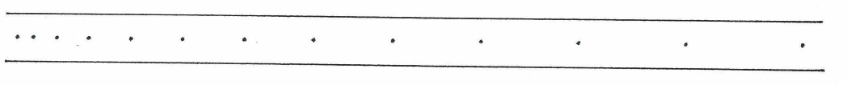

(a) Describe the type of motion shown by the tape.

(b) Choose any 6 dots (5 dot-spacings) and answer the following questions.

(i) How long is the time for 5 dot-spacings?

(ii) Accurately measure the distance for the 5 dot-spacing and record it in centimetres and convert it to
metres.

d = cm = m

(iii) Calculate the speed represented by the dots you have chosen. Show your working.

3. A car moves off from a standing start with a uniform acceleration. It reaches 20.0 ms⁻¹ after 8.00 s before
maintaining its speed for another 15.0 s. As it approaches a set of lights, it brakes uniformly to 8.00 ms⁻¹ over
12.0 s before stopping for a red light.
(Assume the movement has occurred on a straight road.)

(a) Draw a velocity - time graph for the entire motion.

(b) By finding the gradient, calculate:

(i) the acceleration at the start of the motion.

(ii) the deceleration as the car approached the second set of lights.

(c) From the area under the graph, determine the displacement of the car over the entire motion.

4. A balloon filled with hydrogen gas has a velocity of 40 ms⁻¹ East. How long will it take to go 450 m ?

5. What is the average speed of a plane if it flies 2700 km in 2.3 hours? Give the answer in kmh⁻¹.

6. A top sprinter reaches 11.2 ms⁻¹ within 3.15 s of the start of a race. Calculate the average acceleration.

7. A car of mass 1530 kg is travelling at 70.0 kmh⁻¹ along Hepburn Avenue when the driver has to brake sharply to
avoid a small child who suddenly appeared on a bike crossing the road.

(a) Convert the velocity of the car to ms⁻¹.

(b) If it took 3.5 s to stop the car, calculate the average force exerted by the brakes.

(c) The driver of the car was an engineer and had a hard-hat sitting on the back shelf. Describe what
happened to the hard-hat in this situation and explain why it took place.

8. (a) Explain the difference between mass and weight. Give an example to help your explanation.

(b) The acceleration due to gravity on Jupiter is 22.5 ms⁻². Calculate the weight of a 450 kg object on Jupiter.

9. A 70.0 kg cyclist is applying a force of 150 N forwards but is working against a wind producing a friction force
of 80 N opposing the movement.

(a) Determine the resultant force for this situation.

(b) Calculate the acceleration of the cyclist.

(c) It is possible for the rider to move at constant velocity. In terms of the forces acting, explain how this is
possible.

10. You are seating on a seat at the moment. Explain why you don't fall through the chair and are supported by it.

